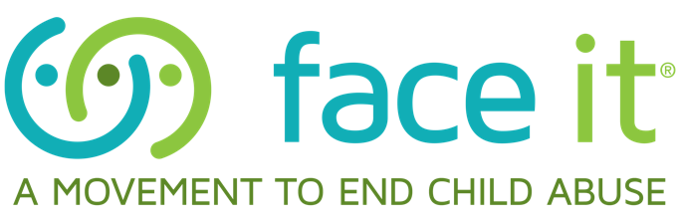

TIPS FOR EDUCATORS
PREVENTION, RECOGNITION AND REPORTING CHILD PHYSICAL ABUSE

Know the Signs:
Knowing the signs of child abuse and neglect is an essential tool for anyone working with children. Make note of the warning signs below.
• For a child of any age, bruising to the ears, neck, torso, buttocks, or genitals
• Burns on a young baby or child, such as those caused by cigarettes or immersion in hot water
• Pain when toileting, frequent yeast infections or urinary tract infections, or any sexually transmitted disease or related symptoms could be signs of sexual abuse
• Aggression toward peers, pets, other animals
• Sudden changes in behavior or unexpected drop in grades
• Seems afraid of parents or other adults

Know the risk factors:
There are many frustrating aspects of taking care of a child. Be sure to know and educate parents and other caregivers about these potential triggers.
• It is important to have realistic expectations of a child’s development at a given age. Unrealistic expectations often lead to frustration and abuse.
• Substance abuse is often associated with child physical abuse or neglect. Children should never be left in the care of individuals who are under the influence of a mind-altering substance, including pain killers and “nerve pills.”
• A new adult in the home can be a time where children are at a higher risk of abuse or neglect, whether it is a parent returning from jail or prison, a parent in the military returning from a deployment, or a new partner or significant other.
• Intimate partner violence is often associated with child physical abuse. If you see evidence that a child’s caregiver has hit, kicked, shoved or threatened another with physical violence – he/she should NOT be caring for a young child.
• If you witness an event that causes you concern, document the situation and consider reporting it to authorities.
• Document all injuries that occur on children while they are in your care. Include how, when, and where the injury occurred, and what action you took to address it. If a child arrives at school with a new injury, inquire about it, document it, and if it concerns you, report it.
Become a source of support and sound information for parents and caregivers:
• Develop a resource board by the area where parents usually sign in and display local resources such as 211 or fliers about housing, food, clothing, counseling and other special needs.
• Listen without judgment.
• Make parents aware of the hotline 1-800-CHILDREN to talk to a trained volunteer for information, support, and referrals to services in your area.
• Recommend that parents and caregivers keep a list of phone numbers on hand that they can call for support.
• Step in. Be supportive. Respond in positive ways. Ask “How can we help you?”
• Make space available for staff to meet with parents privately.
• Maintain confidentiality when parents share sensitive or private information.

Report
Keep hotline contact information visible in the office and ensure that staff is trained on recognition and mandated reporting. By law, school teachers and school officials must report suspected child abuse if you have knowledge or reasonable cause. To report suspected abuse or neglect in Montana:
• call the Montana Child Abuse Hotline toll free 24/7 at 1-866-820-5437

This information is adapted from material by The Face It® Movement, an initiative led by Kosair Charities in the state of Kentucky. For more information visit their ​website at https://faceitabuse.org/

